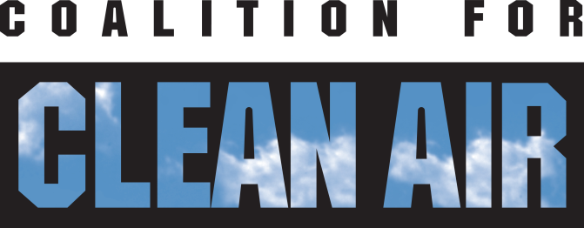

**Job opportunity- Policy & Outreach Associate**

* **Full-time position**
* **Based in downtown Sacramento**
* **Ability to start: Fall 2019**

Established in 1971, the non-profit Coalition for Clean Air (CCA) is California’s only statewide organization exclusively advocating for healthful air. CCA is dedicated to protecting public health, improving air quality, and preventing climate change. CCA is known for spearheading innovative policies, such as clean car standards and targeting climate investments to the communities that suffer the worst pollution and historic disinvestment. With offices in   
Los Angeles and Sacramento, CCA achieves its goals through policy advocacy, public education, and partnering with diverse stakeholders.

**About the Position**

The Policy and Outreach Associate is a key member of Coalition for Clean Air’s team, engaging in the development and execution of CCA advocacy efforts and educational campaigns. Our priority policy campaign objectives include ensuring that climate funds are invested wisely in low-income communities of color, cleaning up the freight system, and electrifying transportation. Outreach job responsibilities include working with contractors, school administrators, teachers, students, and funders to build the educational capacity of California schools to teach students about air quality and the use of air quality sensors.

The position requires an individual comfortable working in a team setting while also being able to work independently and take initiative. The Policy and Outreach Associate is based in downtown Sacramento and reports to the Policy Director and Air Quality Monitoring Program Manager. The ideal candidate should be able to work 40 hours a week, including occasional weekends and evenings when needed. This position requires substantial discretion in determining how to meet assigned goals and competing deadlines.

**Duties and Responsibilities**

* Advocate for CCA’s positions in regulatory proceedings, legislative hearings, and other venues where air quality decisions are made.
* Analyze complex policy issues related to air quality and climate change and write fact sheets, blogs, comment letters and other clear and concise documents about those issues.
* Build relationships with manufacturers of advanced clean vehicles and equipment.
* Coordinate and participate in educational forums and meetings with elected and appointed officials.
* Inform and involve community groups in clean air advocacy and education.
* Collaborate, lead and build coalitions with other public-interest advocates, businesses, labor unions and other interests.
* Coordinate education program activities with teachers, students, scientists, and policymakers.
* Communicate with media.
* Work with development staff to help with fundraising to support CCA programs.
* Support the Policy Director and Air Quality Monitoring Program Manager in a variety of advocacy, organizing and communications tasks.

**Position Qualifications**

Qualified individuals should be able to demonstrate the following skills and experience:

* At least 2 years of work or related experience in policy analysis or development and communications or outreach activities, preferably on air quality or other environmental issues.
* Experience working with middle school and high school administrators, teachers, and students preferred
* Education: Bachelor’s degree (B.A./B.S.) in Environmental Studies, Public Policy or related discipline.
* An equivalent combination of education and experience may be accepted as a satisfactory substitute for the specific education and experience listed above.
* Ability to think strategically and act diplomatically while working well with others.
* Analytical and problem-solving abilities with an attention to detail.
* Ability to communicate effectively in writing and verbally.
* High level of computer literacy with advanced knowledge of information technology systems.
* Bi-lingual in English and Spanish preferred.
* Passionate about air quality and environmental justice.

**Physical Demands**

* 70-85% of time sitting; 5-15% of time standing; and 5-15% of time walking.
* Less than 5% of time lifting, carrying, pushing or pulling up to 50 lbs.
* Less than 10% of time kneeling, balancing, reaching, crawling, crouching or climbing.
* More than 65% of time using eye, hand and finger coordination and more than 40% of time using a computer (keyboarding) and telephone equipment.
* Some travel is required.

**Compensation**: $43,000 - $48,000/year depending upon qualifications and experience, plus a generous benefits package.

**Additional Information:** The responsibilities listed here are illustrative of the essential functions of the job and do not include nonessential or marginal duties that may be required. CCA reserves the right to modify or change the duties and essential functions of this job at any time. Nothing in this job announcement should be considered as an offer or guarantee of employment.

*Interested applicants should submit a cover letter and resume in .pdf format to* [*jobs@ccair.org*](mailto:jobs@ccair.org)*, subject: Policy and Outreach Associate Position. Coalition for Clean Air is an Equal Opportunity Employer. Women and people of color are encouraged to apply. Position will remain open until filled.*