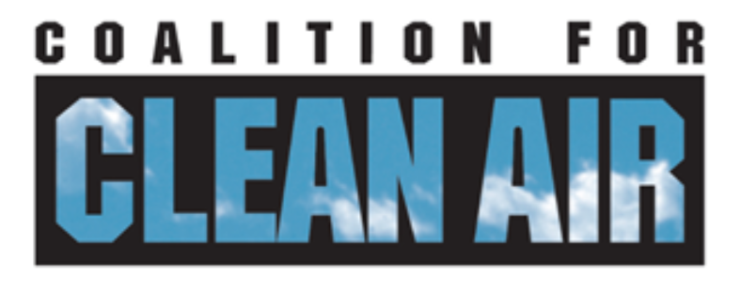
2026 Advocacy Intern
Organization: Coalition for Clean Air (CCA)
Location: Remote (California)
Time Commitment: Flexible schedule, with availability for regular virtual check-in meetings. 3-5 hours per week/9-10 weeks. Summer and/or Fall 2026.
Reports To: Policy Advocate or designated staff member
About the Coalition for Clean Air: Established in 1971, the nonprofit Coalition for Clean Air (CCA) is California's only statewide organization exclusively advocating for healthy air. CCA is dedicated to protecting public health, improving air quality, and preventing climate change through policy advocacy, public education, and partnering with diverse stakeholders.
Position Summary: The Advocacy Intern will play a supportive role in CCA's advocacy and outreach efforts to reduce air pollution in the South Coast Air Quality Management District. With 17 million people, this air district is the smoggiest in the country and in severe non-attainment for air quality. The intern will assist CCA in developing a long-term plan for outreach to decision makers in the region--city councilors, mayors, and other key stakeholders-- to specifically educate them on the challenges and opportunities for addressing air quality issues in their districts. The intern will help ensure the organization has accurate and up-to-date contact information for key California policymakers and government officials by building an updated listserv and database, developing outreach materials, and conducting targeted outreach to these stakeholders. This role is ideal for a detail-oriented, self-motivated individual interested in California environmental policy and advocacy.
Key Responsibilities:
- Research and verify contact information (email addresses, phone numbers, office addresses) for city councilors, mayors, and other key stakeholders in the South Coast Air Quality Management District (ex. SCAG, COG, etc). Utilize public databases, official government websites, and legislative tracking tools to compile and update contact lists.
- Organize and maintain data in a clear, consistent format (e.g., a shared spreadsheet or database).
- Develop communications materials to these targets to educate and inform them about localized air quality issues. These may include but are not limited to, a monthly newsletter delivered to emails, physical handouts/flyers, social media posts about local city air quality issues, etc. Collaborate with CCA communications and policy staff to do this.
- Set up meetings with policy makers to get their feedback on these priorities, deliver materials, and begin to develop long-term relationships with these offices and CCA.
- Communicate with CCA staff to confirm research priorities and report on progress.
- Participate in regular virtual check-in meetings with CCA staff.
Qualifications and Skills:
- Strong research and information-gathering skills, particularly using online resources.
- Excellent attention to detail and organizational skills.
- Proficiency with basic computer skills, including Microsoft Excel or Google Sheets.
- Ability to work independently, manage time effectively, and meet deadlines.
- Interest in environmental issues, public policy, and the legislative process in California.
Benefits:
- Gain direct experience supporting a leading statewide environmental advocacy organization.
- Learn about the structure of California regional government and policymaking.
- Potential for involvement in additional advocacy work and outreach as needs and interests align.
Send Cover Letter and Resume to dori@ccair.org by March 15th for summer 2026 and August 1st for fall 2026 internship positions.

